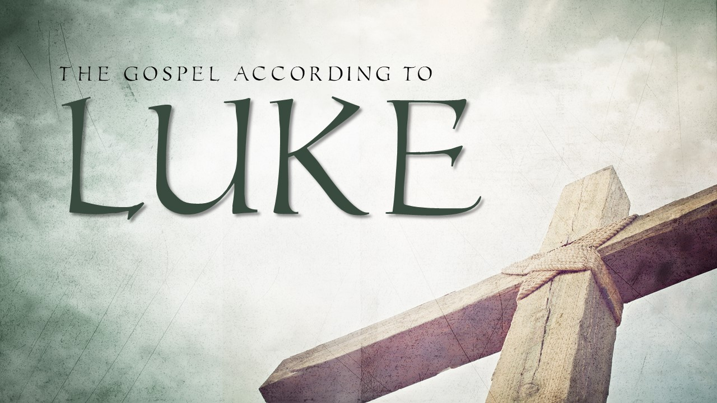
Session 1 Luke 1:5-25

Subject: Trust
Central Theme: Choosing to Trust
Objective Sentence: We must choose to trust God through three seasons of life.
Keyword: Seasons

1. The Season of Silence. V. 5-17

2. The Season of Doubt. V. 18-20

3. The Season of Provision. V. 21-25

Introduction:

Connection:
- Today we begin a study through the book of Luke.
- The Gospel of Luke is a telling of the history of Jesus’ life, death, burial, and resurrection for our sins written to us by Doctor Luke.
- Luke, being a doctor, writes with great detail the firsthand accounts of the life of Christ for us.
- This Gospel is the first of two parts of one work, the second being the Acts of the Apostles.
- As we begin this study, we are going to look at several passages that will get us ready for this Christmas season.

Tension:
- I want us to think about that word “season” for a moment.
- Growing up in Florida, I did not experience the seasons like we do up here in Ohio.
- In Florida there are only three seasons- Kind of hot, Hot, Really hot.
- One of the things that I have enjoyed these last few years is the change of season- Winter, Spring, Summer and Fall. All have unique attributes and bring about both beauty and challenges.
- This is also true of life. There are many seasons in life.
- Some seasons last just for short time, and others go on for some time.
- Our country certainly is in a season of great trouble and chaos.
- We are dealing with difficulty on many levels.
- This past week we had two funerals in our church. We have had several people go on to be with the Lord.
- We have had some who have been sick. Many are getting better!
- How many of you have asked God to get you through a season like this?
- I have prayed that this season would end, and God has not yet answered my prayers.
- In every season of life, it is important for us to trust God through obedience and faith.
- In today’s text we get to see an example of some people that had to choose to trust God through some seasons.
- You see, if God is going to use us as a church, we must trust Him. We should not expect God to use us if we are not willing to put our trust in Him.
- By studying this passage today, I want us to walk away trusting God even more in the season that we are in.
- I want us to do that by seeing that…

We must choose to trust God through three seasons of life.

1. The Season of Silence. V. 5-17

Explanation:
- In today's text we see Zacharias being visited by an angel.
- Who is he that he would be visited by an angel? What brought this circumstance about?
- Well, after Luke introduces the work to the reader, Theophilus (v.3), he begins the story of the coming of Christ by starting with this Zecharias.
- We know a few things about Zecharias from verses
  - He was a priest that worked in the temple. (v.5)
  - He was married to Elizabeth. (v.5)
  - According to the inspired Word of God, they were both righteous and blameless before God. (v.6)
  - They were without children and were beyond the childbearing years. (v.7)
  - He had been chosen to burn incense before the Lord. (v.8-9)
- Culturally there would have been shame and sadness for Elizabeth in her bareness. As people that loved the Lord, they would have certainly made this a matter of prayer, just like Hannah in the Old Testament. (I Samuel 1:10-11)
- Imagine going from your youth into old age asking God for a child.
  - Year after year you pray and fast.
  - Year after year, there is no child.
  - You celebrate the births of the other families in your community. You wonder when the same blessing would come to you.
  - You pray and it seems as if God does not answer, and you may be tempted to think that God does not care.
- It was during this time that he was inside the temple doing these priestly duties while a large group of people waited on him outside.
- In that moment of solitude, an angel, later identified as Gabriel, supernaturally appeared to Zacharias on the right side of the altar of incense. (v.11)
- This appearance brought fear into the heart of Zacharias, as it would to most people. (v.12)
- The angel quickly calmed his fears and gave him some incredible news.
(13) But the angel said unto him, Fear not, Zacharias: for thy prayer is heard; and thy wife Elisabeth shall bear thee a son, and thou shalt call his name John. (14) And thou shalt have joy and gladness; and many shall rejoice at his birth.
- The angel told him that his prayers had been answered.
- The season of silence was over.
- He told him that his wife, Elisabeth would have a son, and even told him what to name the son. His name would be called John.
- The angel also described what would be true for people at his birth. There would be joy and gladness. The scripture says that many will rejoice at his birth.
- This is a theme through the book of Luke, so pay attention to this kind of phrase as we study.

Application:
- As we look back at this passage as history, we know that God had an incredible plan for Zecharias and Elisabeth's baby boy.
- He had prophesied years before about this forerunner of the Messiah.
- Put yourself in the place of these two people though.
  - They had given their lives to the Lord, they were blameless before God, and they passionately desired to have children.
  - They prayed for this through the years where their friends were having children.
  - They prayed and prayed, and God never answered their prayers.
  - It may have been tempting to doubt God in those moments. It would have been difficult to understand why.
  - The good news is that these two people of God lived a life of faithfulness even when they did not know God's plan.
- Our life can be the same. We can pray and ask God for our desires, and there are times when we do not get the answer we want.
- It is in those times where we must trust God.
- His plan and His ways are best. He can be trusted more than anyone else. Do not stop praying. Keep trusting God.

Explanation:
- Not only was Zechariah’s prayer answered in that he would have a son, but his son would be used by God in an incredible way.
- We see Gabriel describe the nature of John's birth, life, and ministry in verses 15-17. What did the angel say about this baby?
(15) For he shall be great in the sight of the Lord, and shall drink neither wine nor strong drink; and he shall be filled with the Holy Ghost, even from his mother's womb.

1. He will be set apart by God, Himself. (v.15)
- This is some statement that is made about this child!
- What an incredible thing to be said about your kids.
- The description in verse 15 makes it clear that John would take a Nazarite vow.
  - There were several famous Nazarite's in the Old Testament. It was always a way of being set apart for use by God.
  - The person most known for being a Nazarite is Samson.
  - Samuel was also known to be a Nazarite. Hannah promised God he would be a Nazarite when asking the Lord to end her barrenness. (1 Samuel 1:11).
  - In verse 17, we see that John's ministry would be compared to Elijah's.
(17) And he shall go before him in the spirit and power of Elias
  - Some have deduced that Elijah may have been a Nazarite as well.
    - King Ahaziah identified Elijah from a description in 2 Kings 1:8 where it says, “(8) And they answered him, He was an hairy man, and girt with a girdle of leather about his loins. And he said, It is Elijah the Tishbite." Both Elijah and John lived in the wilderness. Both Elijah and John spoke boldly to people in power and were tormented by kings and their queens. Both had moments of doubt about their ministry and were affirmed by God in what He was doing beyond them.
- What was being made clear to Zecharias is that this child would be set apart to be used by God in a special way.

2. He will lead a movement of repentance in preparation of the Messiah. (v.16-17)
(16) And many of the children of Israel shall he turn to the Lord their God
- Verse 16 foretells of the success that John would have with some of the people of Israel. There will be many who "turn to the Lord their God".
- This is a good description of repentance.
- The Old Testament ends in the book of Malachi's last two verses that speak of this coming forerunner of the Messiah.
(5) Behold, I will send you Elijah the prophet before the coming of the great and dreadful day of the LORD: (6) And he shall turn the heart of the fathers to the children, and the heart of the children to their fathers, lest I come and smite the earth with a curse. Malachi 4:5-6

- Notice how closely this relates to the description of the ministry of John in Luke 1:17.
(17) And he shall go before him in the spirit and power of Elias, to turn the hearts of the fathers to the children, and the disobedient to the wisdom of the just; to make ready a people prepared for the Lord.

- When there is preparation for something it gives some clue to something that is yet to come.
- Often the more preparation that is needed, the more significant the event.
  - Just think about all the preparation that goes into many weddings.
  - Choices are painstakingly made over clothing, flowers, decorations, schedule of service, venue, food, candles, who will be in the wedding, who will perform the wedding, the date, the time, and the budget involved- all for a 45 minute ceremony and 3 hour reception.
- There is a preparation being made here for an incredible event.
- The preparation includes all kinds of prophecy given not only about the Messiah when he comes, but this forerunner that prepares the way for His ministry.
- Think about this phrase "to make ready a people prepared for the Lord."
  - This could be seen in a general sense meaning a group of people that were being prepared.
  - Yet, we also know that there were specific individuals who had been prepared by John.
    - The Two Disciples
      - Andrew was one of the two apostles standing by John when he declared Jesus as the Lamb of God in John 1:35-37. We know this because in John 1:40 it says that one of those disciples was Andrew, and of course, he was instrumental in inviting Peter to see Jesus.

    - Apollos
      - The scripture also tells us that Apollos was a follower of John in that this was the content that he knew about Jesus before being taught by Aquila and Pricilla.
And a certain Jew named Apollos, born at Alexandria, an eloquent man, and mighty in the scriptures, came to Ephesus. (25) This man was instructed in the way of the Lord; and being fervent in the spirit, he spake and taught diligently the things of the Lord, knowing only the baptism of John. (26) And he began to speak boldly in the synagogue: whom when Aquila and Priscilla had heard, they took him unto them, and expounded unto him the way of God more perfectly. (27) And when he was disposed to pass into Achaia, the brethren wrote, exhorting the disciples to receive him: who, when he was come, helped them much which had believed through grace: (28) For he mightily convinced the Jews, and that publickly, shewing by the scriptures that Jesus was Christ. Acts 18:24-28
Application:
- Do you see what was being revealed to Zecharias and Elizabeth?
- They had been asking for a child, and from their perspective they could have believed that God was not at work.
- Yet, God was at work. He had a purpose and plan that he had been working on before the foundation of the world.
- He had prophesied about the answer to their prayers in the Old Testament!
- He had an incredible future planned not just to provide them a child, but for the redemption of the entire world.
- When God is silent, we must choose to trust God.
- Do not mistake God’s silence for God’s absence.
- How did God want to use John? He wanted to use John to prepare people for the Messiah.
  - Repentance is often the prerequisite decision that we must take to be able to be used by God in a significant way.
  - The preparation for the Messiah was made by repentance in the heart of the people.
  - It was also made by John being a witness and testimony to the true identity of Jesus as Messiah and Lord.
- In a way every believer of Christ should help to prepare others for what God wants to do in them.
- How do we do this? We call people to repentance and we point people to Jesus!
- We ought not to do this hypocritically.
- This means that we must be quick to repent and to believe in Jesus, not just for our salvation, but for our sanctification as well.
- We do not just repent and believe in Him so we can go to heaven. We repent and trust so that we can live lives that honor God and give us a platform for reaching others.

We must choose to trust God through three seasons of life.

1. The Season of Silence. V. 5-17

2. The Season of Doubt. V.18-20

Explanation:
- When we read this passage, it may be easy for us to be hard on him.
- There is reason for some to be that way toward him.
  - Think about the fact that he is talking to an angel who is telling him the future about his Son because God sent Him with the message.
  - It is already extraordinary.
  - If God can do all of this in a supernatural way, then human, natural limitations should be no problem.
- Yet, Zacharias shares doubt with the angel.
- In verse 18 he questions if what the angel is saying is possible because of his age.
(18) And Zacharias said unto the angel, Whereby shall I know this? for I am an old man, and my wife well stricken in years.
- It is unusual for the elderly to have children. But God had done it before.
- This same kind of scenario had happened with Abram and Sarah.

Then Abraham fell upon his face, and laughed, and said in his heart, shall a child be born unto him that is an hundred years old? and shall Sarah, that is ninety years old, bear? Genesis 17:17

- God had shown Himself faithful to Abraham and Sarah, and He was going to do it again for them.
- And yet, Zecharias doubted.
- Notice the angel's response:
(19) And the angel answering said unto him, I am Gabriel, that stand in the presence of God; and am sent to speak unto thee, and to shew thee these glad tidings.
- He points out two realities to Zacharias that should have assured him of the veracity of the angels’ message.
  - First, he points out his identity. The message could be trusted as true because of who is giving the message.
  - Second, he points out the source of the message. The message was true because God is the one who sent the message to Zachariah.
- The angel of God gives a sign to Zacharias to affirm the veracity of the message.
(20) And, behold, thou shalt be dumb, and not able to speak, until the day that these things shall be performed, because thou believest not my words, which shall be fulfilled in their season.
- He makes him unable to talk until the baby is born. His inability to speak would be a constant confirmation of what God was going to do about this child.

Application:
- It must be pointed out that we before we are too harsh on Zacharias, we must admit our own doubt to God.
  - We have the Word of God in our hands.
  - Many believers where I minister have several copies of God's Word available to them.
  - We have the death, burial, and resurrection of Christ as a historical perspective.
  - God has proven himself to be God throughout history, and yet there are times that we doubt.
- How do we doubt God?
  - We doubt Him through prayerlessness. There are times we do not ask God to do things in our lives because we assume He will not or cannot do them.
  - We doubt Him through sinfulness. We show our doubt to God at times by doing things we know He is against. We doubt that His ways are best for us and move in disobedience away from Him.
- God can be trusted. He has given us reason to trust Him throughout history and in His Word.
- Remember, faith cometh by hearing and hearing by the Word of God.

Response:
- Are you doubting God today? Are you doubting him through prayerlessness? Are you doubting him in sinfulness? Repent and believe!

We must choose to trust God through three seasons of life.

1. The Season of Silence. V. 5-17

2. The Season of Doubt. V.18-20

3. The Season of Provision. V.21-25

Explanation:
- There is a scene change in verse 21.
And the people waited for Zacharias, and marvelled that he tarried so long in the temple.
- Zacharias goes back out to the people that had waited on him.
- They had been wondering why his service had taken so long.
- When he came back there was evidence that something had happened inside.
(22) And when he came out, he could not speak unto them: and they perceived that he had seen a vision in the temple: for he beckoned unto them, and remained speechless.
- The pronouncement by the angel that Zacharias would be mute was instantaneous.
- He tried to communicate with the crowd gathered there but was unable to tell them what happened verbally.
- They perceived rightly that there was some kind of vision that was seen. Zacharias finished his duty and went home. Notice what happened next:
(24) And after those days his wife Elisabeth conceived,
- They believed God in their old age and conceived a son. It was miraculous in that God made it possible in their old age for them to conceive.
- Elizabeth must have been so overjoyed to finally have her prayers for a son answered. She had prayed, and God answered in a way that was more than she would have ever known. She declares this in verse 25. She says that her "reproach" was taken away. She was no longer one that had been "cursed" by God but had been blessed by God and shown His favor.
…and hid herself five months, saying, (25) Thus hath the Lord dealt with me in the days wherein he looked on me, to take away my reproach among men. Luke 1:21-25
- When God had provided Elisabeth a Son, she remembered to acknowledge God for what He had done.
- It was so obvious that He had worked, and she acknowledged Him for it.

Application:
- Sometimes we tend to forget God once He has provided for us.
- We begin to think that we are the source of what He have rather than God.
- When God provides, we must continue to trust in Him and not in ourselves. We must thank Him. We must honor Him.
- Remember the bigger picture here. God was preparing the world at many different levels for the redemption that would provide by His Son.
- John was a part of that master plan of redemption.
- He was going to prepare the people for the coming Messiah.
- He was being used to point us to the true identity of Jesus of Nazareth as Jesus the Christ.
- Do you remember John's declaration of Jesus? "Behold the lamb of God that taketh away the sin of the world." The nation of Israel would have understood that language.
  - Millions of lambs without spot or blemish had been sacrificed by shedding their blood to atone for the sins of the people. Consider these verses from Hebrews:
But Christ being come an high priest of good things to come, by a greater and more perfect tabernacle, not made with hands, that is to say, not of this building; (12) Neither by the blood of goats and calves, but by his own blood he entered in once into the holy place, having obtained eternal redemption for us. (13) For if the blood of bulls and of goats, and the ashes of an heifer sprinkling the unclean, sanctifieth to the purifying of the flesh: (14) How much more shall the blood of Christ, who through the eternal Spirit offered himself without spot to God, purge your conscience from dead works to serve the living God? Hebrews 9:11-14
- God was concerned not just with the prayers of Zacharias and Elisabeth, but also about His plan of redemption for all mankind.
- Ultimately the son that Elisabeth would bare in her old age would declare the identity of the Messiah that would die for her sins and redeem her soul.
- That is why for so long his answer looked like a "no" and she would suffer "reproach". God's plan was far better!

- God can be trusted. What He says will happen will come to pass.
- If you ask for something and you get an answer from the Lord that you do not want, know that it is not because He does not love you.
- God loves you and wants what is best for you. He sees the end from the beginning and has an incredible plan in mind. We may not understand our circumstances, and when we do not, we must trust our good and gracious God.

Response:
- Take some time today to pray to God and thank Him that He can be trusted. If you do not know Christ as your Savior, today is the day of salvation.

Conclusion:
We must choose to trust God through three seasons of life.
Keyword: Seasons

1. The Season of Silence. V. 5-17

2. The Season of Doubt. V.18-20

3. The Season of Provision. V.21-25

