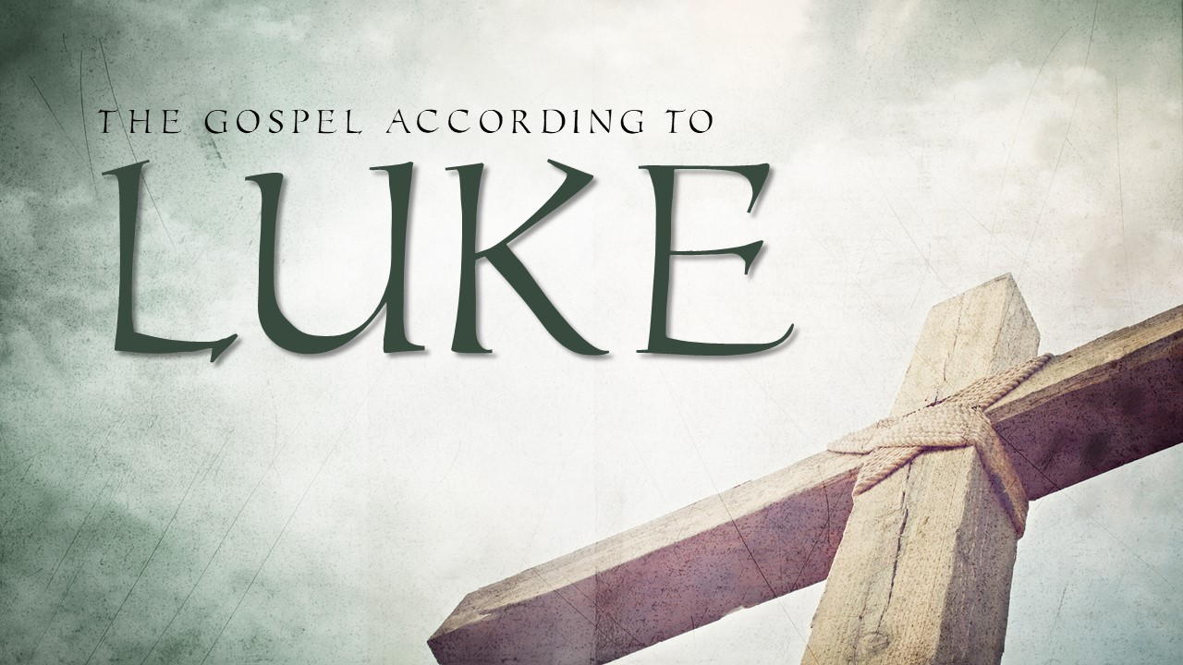
Session 2 Luke 1:26-38

Subject: Redemption
Central Theme: God’s Plan of Redemption
Objective Sentence: We ought to respond to four truths regarding God’s plan of redemption.
Keyword: Truths

God initiated the plan. V.26-27

God uses people. V. 28-31

God became flesh. V. 30-35

God does the impossible. V.36-37

Introduction:

Connection:
- Have you ever been “voluntold”?
- I am a p.k.- preachers kid.
- There were times where my dad pulled the dad card at church. Something we need to be done, and He would get us to do it. He would volunteer us for the job.
- Thankfully, he was wise about it and did not cause us to resent the church or ministry because of it.
- Similarly, at my first summer internship in a church I learned that “we” often meant “me”. I was volunteered for the job, or “voluntold”.
- And again, it is not a bad way to help someone to grow at times, when done wisely.

Tension:
- In today’s text we see God’s call on the life of a young lady.
- She was being told that she was being an excessively big and especially important task. She was being volunteered.
- God was going to use her in His plan of redemption.
- And it was her responsibility to respond to this incredible plan in the right way.
- We have a similar circumstance if we know Christ as Savior.
  - This past week I was able to share the gospel with a new friend.
  - And I one point in the conversation I told Him, “Either this story of Jesus rising from the dead is untrue, or it is the most important thing you’ve ever been told”.
- There is a weight to being given a stewardship of this message of redemption.
- Today, I want you to see four truths about God’s plan of redemption that influenced Mary to respond rightly to God’s call on her life.
- And in seeing these truths it will help us to respond rightly to God’s plan of redemption ourselves.
We ought to respond to four truths regarding God’s plan of redemption.

Truth #1- God initiated the plan. (v.26-27)

Explanation:
- As we continue in our study of the Gospel of Luke, we move into a second narrative in the first chapter.
- Much like the first, it is an accounting of the angel Gabriel announcing a birth.
And in the sixth month
- The words "the sixth month" give us a clue as to the timing of this second announcement.
- It is in the sixth month of the pregnancy of Elizabeth. Luke gives us specifics here.
- Notice what Luke says happened. The angel Gabriel was sent from God.
the angel Gabriel was sent from God unto a city of Galilee, named Nazareth,
- The angel is not sharing his own plan or his own message.
- The angel was commissioned with the message of God to a specific area, city, and woman.
(27) To a virgin espoused to a man whose name was Joseph, of the house of David; and the virgin's name was Mary.
- Two details point to the fact that God is initiating and owning this plan of redemption.
  - First, God chose a woman who was engaged to be married to Joseph, a man "of the house of David".
    - The Old Testament made it clear that when the Messiah comes, he would be in David's line. We will talk more about that later in the passage.
  - Second, we see that the woman God chose was a virgin.
    - She was unmarried and had not ever "known a man".
    - God chose this to be an identification of the Messiah when he came as well.
    - The most specific prophecy about this is found in Isaiah 7:14.

Therefore the Lord himself shall give you a sign; Behold, a virgin shall conceive, and bear a son, and shall call his name Immanuel. Isaiah 7:14

- The name "Immanuel" literally means "with us (is) God".
- Hundreds of years before this moment, God foretold that a virgin would conceive and bring forth a son.
- Now He is sending the angel Gabriel, initiating this part of the plan of redemption, because He is the One who owns this plan.
Application:
- God's love for us is an initiating love. 1 John tells us about this truth when it says:
We love him, because he first loved us. 1 John 4:19

- God entered our history through prophecy, and by giving us revealed signs, so that His plan of redemption would not only happen but be identifiable and revealed to the world.
- We have the opportunity for redemption because He put this plan into motion. This demands our obedience, gratefulness, and worship!
We ought to respond to four truths regarding God’s plan of redemption.

Truth #1- God initiated the plan. (v.26-27)

Truth #2- God uses people. V.28-31

Explanation:
- God initiated this part of the plan of redemption by sending an angel to a virgin named Mary. Notice how the angel greeted her.
(28) And the angel came in unto her, and said, Hail, thou that art highly favoured, the Lord is with thee: blessed art thou among women.
- He called her "highly favoured" and "blessed". God was choosing to use Mary for this incredible responsibility, and in doing so the angel is pointing out the honor that is being given to her in being chosen.
- He also said that "the Lord was with" Mary.
  - God is omnipresent.
  - He is everywhere.
  - This presence though spoke of God's working in Mary's life.
- Gabriel certainly would have understood and experienced God's presence.
- In Luke 1:19 he said about his own experience:
And the angel answering said unto him, I am Gabriel, that stand in the presence of God; and am sent to speak unto thee, and to shew thee these glad tidings. Luke 1:19
- God was choosing to use Mary for this incredible task, and she was taken back by this kind of greeting.
(29) And when she saw him, she was troubled at his saying, and cast in her mind what manner of salutation this should be.

- Just as was the case with Zacharias when he saw the angel, the sudden presence of this supernatural being "troubled" Mary.
- But she was not just troubled at his presence, but in what he said. What did all this mean? It is a natural question.
(30) And the angel said unto her, Fear not, Mary: for thou hast found favour with God.
- Just as was the case with Zacharias, Gabriel told her not to be afraid.
- He told her the specifics of the task for which she was chosen.
- What was this honor and favour leading to for Mary?
- Well to answer that we see the first of three times that the word "behold" is used in this passage.
(31) And, behold, thou shalt conceive in thy womb, and bring forth a son, and shalt call his name JESUS.
- Mary was being chosen by God to supernaturally conceive and birth the son of God. What an incredible task!
Application:
- Much more can and will be said about this conception and birth, but it is right at this point to say that God chose to use people in His plan of redemption.
- To be clear, Mary did not and cannot redeem anyone.
- Only Jesus can save.
- Yet, God chooses people to play the part that they can in sharing his plan of redemption with the world.
- We do what we can do, and in God's plan of redemption He does what only He can do.
- That God would use any of us is not because we are so deserving, but because He is so loving and gracious to us.
- We are truly highly favored to take on this responsibility of participating in this plan of redemption.

We ought to respond to four truths regarding God’s plan of redemption.

Truth #1- God initiated the plan. (v.26-27)

Truth #2- God uses people. V.28-31

Truth #3- God became flesh. V.31-35

Explanation:

In these verses- v.31-35, we see elements that point to both Christ's humanity and His Deity.

Elements of Christ's Humanity in Gabriel's Message:

1. Jesus Christ would be conceived and born of a woman.
(31) And, behold, thou shalt conceive in thy womb, and bring forth a son, and shalt call his name JESUS.
- In this text we see God's plan of redemption unfold through the incarnation of Jesus Christ.
  - Mary would conceive and have a son.
  - God had chosen her to carry His Son.
  - As was the case with Zacharias, Mary was told what the baby’s name would be.
- The baby was named Jesus. Jesus means “Jehovah is salvation.”
- He would have a body- teeth, nostrils, hair, legs, arms, hands, and a belly button.
- He would be carried by Mary for the full term of her pregnancy.
- Mary's water would break, and Jesus would be delivered the same way that every human would be born.

2. Jesus Christ would have the throne of his father David.
(32) He shall be great, and shall be called the Son of the Highest: and the Lord God shall give unto him the throne of his father David:
- To be a son of David means you must be human. To sit on the throne of David is to have a human throne.

Elements of Christ's Deity in Gabriel's Message:

1. Jesus Christ would be supernaturally conceived.
- Mary makes it clear that she has never "known a man" so as to be pregnant.
Then said Mary unto the angel, How shall this be, seeing I know not a man?
- When she asked Gabriel about how this could happen, Gabriel makes it clear that Jesus would have no biological human father.
(35) And the angel answered and said unto her, The Holy Ghost shall come upon thee, and the power of the Highest shall overshadow thee:
- He would be conceived of the Holy Ghost.
- The Power of the Highest would overshadow Mary and she would conceive.

2. Jesus Christ will reign on David's throne forever.
(32) He shall be great, and shall be called the Son of the Highest: and the Lord God shall give unto him the throne of his father David: (33) And he shall reign over the house of Jacob for ever; and of his kingdom there shall be no end.
- To sit on David's throne, Jesus must be human.
- To reign on David's throne forever over the house of Jacob, He must be Divine.
- Jesus' kingdom will be an eternal kingdom! Jesus would be called Great.

3. Jesus Christ would be holy.
(35) And the angel answered and said unto her, The Holy Ghost shall come upon thee, and the power of the Highest shall overshadow thee: therefore also that holy thing which shall be born of thee shall be called the Son of God.
- Because Jesus is conceived by the Holy Spirit with no biological human father, He would be born with no sin nature.
- Jesus was born without sin and was sinless in His life.
- If he was born in sin He would not be able to save us from our sins.
- Jesus was born sinless and remained so because He was God.

For he hath made him to be sin for us, who knew no sin; that we might be made the righteousness of God in him.
2 Corinthians 5:21

4. Jesus Christ is the Son of God.
- All of these elements- His supernatural conception of the Holy Spirit, His birth into the house of David, His eternal reign on the throne of David, and His holy sinless perfection all point to the fact that Jesus Christ is 100% human and 100% Divine. He is the Son of God. He would be called "the Son of the Highest".
therefore also that holy thing which shall be born of thee shall be called the Son of God.
- It is also important to point out at this point that the incarnation of Jesus was not His beginning. When He was conceived in Mary it was when He became flesh. Christ, being God, has always existed.
I am Alpha and Omega, the beginning and the end, the first and the last.
Revelation 22:13

In the beginning was the Word, and the Word was with God, and the Word was God. (2) The same was in the beginning with God.
John 1:1-2

And the Word was made flesh, and dwelt among us, (and we beheld his glory, the glory as of the only begotten of the Father,) full of grace and truth.
John 1:14
Application:
- God's plan of redemption is so incredible.
- He became like us to redeem us.
- He was tempted in all points like we were yet without sin.
- Because He came in flesh, he could bleed and die to pay for our sins.
- Because He is God, born of a virgin and without a sin nature, He was sinless and died on the cross to pay for our sins and none of His own.
- God poured out the punishment we deserved on Jesus.
- Jesus purchased our redemption by His blood and gave us opportunity for our sins to be forgiven.
- He did not stay dead. He rose from the dead so that as He lives, we should live also!
- We can be redeemed because God became flesh.

Response:
- Have you ever accepted Christ's gift of salvation for you? Accept Him today!
- If you have, when was the last time you thanked Him for it?
- When was the last time you shared this truth with someone?
- You might be thinking, “Oh yeah, but you don’t know me. God can’t forgive someone like me.”
- “You don’t know that person. They are too far gone.”
- Can I tell you this last truth about God’s plan of redemption that we’ll look at today?

We ought to respond to four truths regarding God’s plan of redemption.

Truth #1- God initiated the plan. (v.26-27)

Truth #2- God uses people. V.28-31

Truth #3- God became flesh. V.31-35

Truth #4- God does the impossible. (v.36-37)
Explanation:
- Mary's question was certainly an understandable one.
(34) Then said Mary unto the angel, How shall this be, seeing I know not a man?
- When Gabriel announced the birth of John, Zechariah also had a similar question.
- How can these things be...?
  - One child born to parents well pass the childbearing years seems highly improbable.
  - A child born from a woman who was a virgin is humanly impossible.
- The angel let Mary know that God was also at work in her cousin's life.
(36) And, behold, thy cousin Elisabeth, she hath also conceived a son in her old age: and this is the sixth month with her, who was called barren.
- Why did he bring it up? He makes it clear in verse 37.
(37) For with God nothing shall be impossible." Luke 1:36-37
- When it comes to our redemption so much could seem impossible.
  - We were God's enemies.
  - We deserved God's wrath.
  - We deserved hell.
- But God in His mercy became like us.
- He took on flesh so that He could pay our debt.
- To make it happen He did things that our impossible for us, His creation.
- But for Him, our Creator, nothing shall be impossible.

Application:
- There have been times where I have spoken to people about the Gospel and their response to it is that they feel like it is impossible for God to forgive them.
- God loves you and will forgive you of your sin if you call on the Lord to save you.
- There have been some that seem so far from God that we may thing "they are too far gone."
- I want you to know that God is a God who is in the business of doing the impossible. With God nothing shall be impossible.
- When it comes to God's gift of redemption, we must think the way He does. We must have faith and believe that with Him nothing shall be impossible.
Response:
- Who have you not shared the Gospel with because you thought that they were too far gone or would never respond to it?
- Have you believed that forgiveness from God is impossible? Remember, God does the impossible.

Conclusion:
- How should we respond to God's plan of redemption?
- One last detail of this passage gives us an example of how to respond to God's plan of redemption.
- There is a third "behold" in this passage.
  - The first "behold" was told to Mary by Gabriel when she was told how she was favored by God to carry Jesus.
  - The second "behold" was told to Mary by Gabriel when he was sharing with her about Elisabeth's conception in her old age.
- This time Mary says "behold" to Gabriel.
And Mary said, Behold the handmaid of the Lord; be it unto me according to thy word. And the angel departed from her. Luke 1:38
- She uses this very descriptive word that gives us the right way to respond to God’s plan of redemption.
- She declares herself "the handmaid of the Lord".
  - The word translated "handmaid" is the female form of the word for "slave".
  - Mary describes herself as the slave of the Lord.
  - She is fulling submitting to the task that has been assigned to her.
  - Her response to God is complete surrender to what He wants her to do.
- Taking on the responsibility would not be easy.
  - She would have the normal burden of childbearing that is challenging enough.
  - Mary would also have to do this in a culture where unwed pregnancy was the source of all kinds of shame in the community.
  - Certainly, her relationship with her betrothed would be at risk.
- She must have had so many questions.
  - When I start to show, what do I say?
  - What will my parents think?
  - What will Joseph think? Will he end our engagement?
  - How will I raise the Son of God without a husband and father?
- It is not wrong for her to have these kinds of questions, especially when her first response before the questions is, "Behold, the handmaid of the Lord; be it unto me according to thy word."
- All the other concerns were coming under umbrella of her submission to God.
Application:
- What an incredible example to us!
- We can certainly see evidence in the life of Mary that she was a wise choice for this task.
- If it is true that
  - God initiated the plan of redemption,
  - God became flesh so that he could purchase our redemption,
  - and God does the impossible as part of his plan,
  - then we He calls on us to be used in that plan the only right response is submission.
Response:
- If you are lost, know that God is calling on you to be redeemed. God sent Jesus to die for you and rise again. Submit to His plan and be saved today!
- Believer, God wants to use You. Who is God asking you to talk to about Him? Let us submit to God's will for our lives.
- May we respond to God today in this way: "Behold, the servant of the Lord. Be it according to Your Word!"

