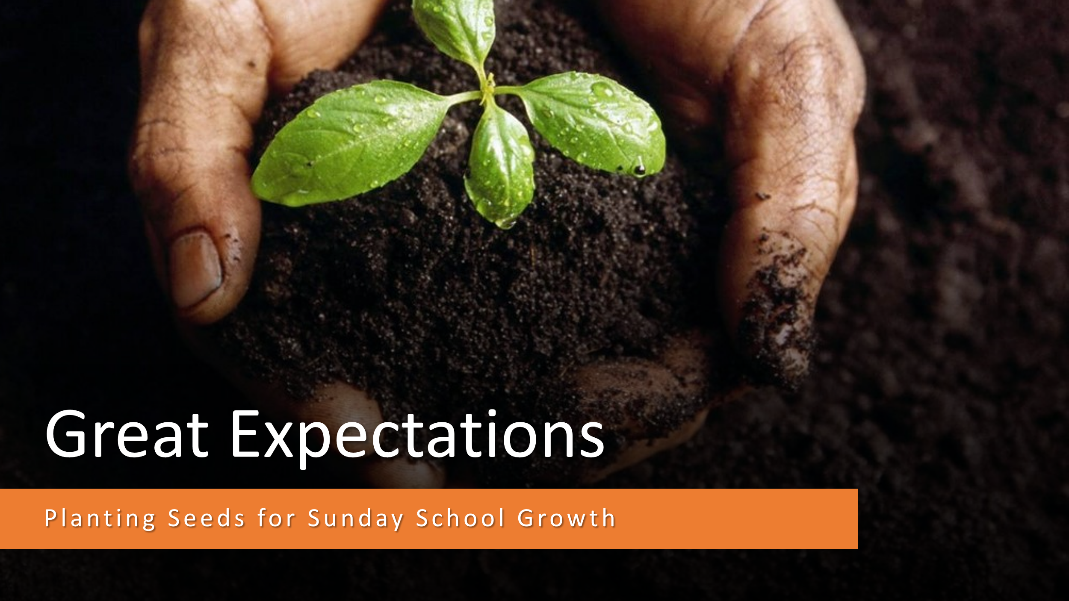
Session 1
- Welcome to our Great Expectations Sunday School Training. I am so excited that you are here. We are going to have a great time today. We are going to talk about some great things.
- I want to start out by saying to you that I am grateful for every person in this room.
- God has used you, and many people like you in this churches history to do some amazing things for the Lord.
- I believe that this church has an incredible history, and by God’s grace I believe it has an incredible future. This is what we’ll be talking about today.
Matthew 4:23 And Jesus went about all Galilee, teaching in their synagogues, and preaching the gospel of the kingdom, and healing all manner of sickness and all manner of disease among the people.
Mark 3:13-15 And he goeth up into a mountain, and calleth unto him whom he would: and they came unto him. (14) And he ordained twelve, that they should be with him, and that he might send them forth to preach, (15) And to have power to heal sicknesses, and to cast out devils:
Matthew 28:18-20 And Jesus came and spake unto them, saying, All power is given unto me in heaven and in earth. (19) Go ye therefore, and teach all nations, baptizing them in the name of the Father, and of the Son, and of the Holy Ghost: (20) Teaching them to observe all things whatsoever I have commanded you: and, lo, I am with you alway, even unto the end of the world. Amen.
- The mission of the church is the Great Commission.
- The largest organization in the church is the Sunday School.
- If the Sunday School is not a great commission organization, then we will have a difficult time being a great commission church.
- So our church, and our Sunday School has three tasks.
  - Reach people.
  - Teach people.
  - Minister to people.
- When we reach people, we will see salvation.
- When we teach people, we will see discipleship and obedience.
- When we send people out to minister, we will see service and mission.
- Whenever we meet with our leaders this is what I will ask- What are the three tasks of Sunday School?
- We reach people, teach people, send people out to minister.
- Let’s try it!

- Now, there are seeds scattered on the table in front of you. I want each of you to pick up a seed and put it in the palm of your hands.
- I’m going to ask you a question that has a one-word answer.
- All I want you to do at first is think of a one word answer, but don’t say it out loud.
What do you see?
- Do you have the word? Ok on the count of three, give me your answer. 1, 2, 3….
- Ok… tell the people at your table what your answer is:
  - Many people when you ask them this question just see the seed.
  - And of course if they were just talking about what they could visually see, they would be exactly right.
- Now I am going to say a word that has some meaning that comes along with it. After I say this word, I will ask you the question again, and this time I want to think of a one word answer.
The word is Vision.
- Ok… now we are going to repeat this process.
- Here is the question: Don’t blurt out the answer. Think of a one word answer.

What do you see?

- Ok…Now that you have the word in your mind, say it out loud on the count of three- 1-2- 3!
- How many of you said:

  - Pumpkin?

  - Pumpkin patch?
  - Pumpkin Pie?
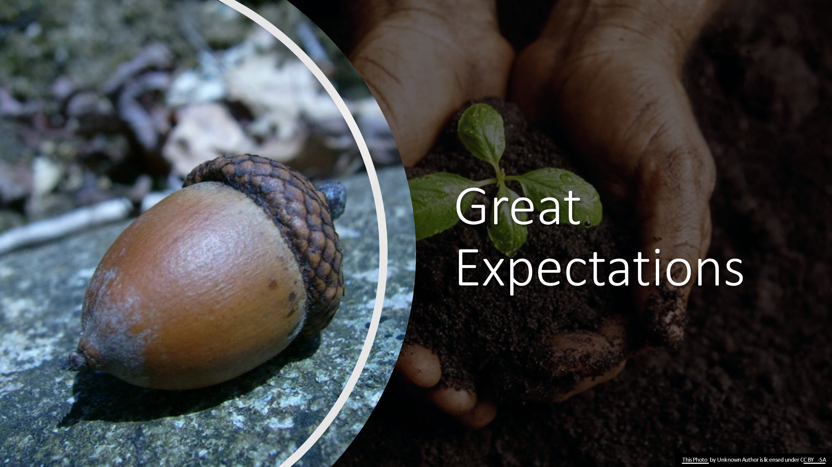
  - Pie business?
- We could do the same thing with an acorn.

- What can you see with an acorn?
  - Some people see the acorn.

  - Some people see the tree.
  - Some people see a forest.
  - Some people see the chance to make something (woodworking tools.)

  - If you’re into guitar, maybe that is what you see!

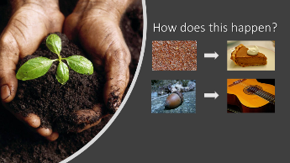
- What is it that gets us from seed to crop? What gets us from a seed in a pouch or on a plant to a fully mature plant, fruit, dessert, or guitar?
- The answer is Stewardship.
- Vision leads to expectation. Expectation leads to stewardship.
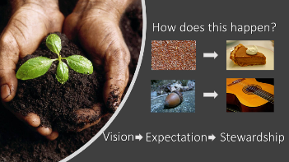
- To go from seed to plant to crop to harvest takes stewardship. There isn’t any one action that is the magic action that gets a plant to yield a lot of fruit. There are a myriad of things that a farmer has to do to see bring in a harvest.
  - He must prepare the soil- plow the ground.
  - He has to plant the seed.
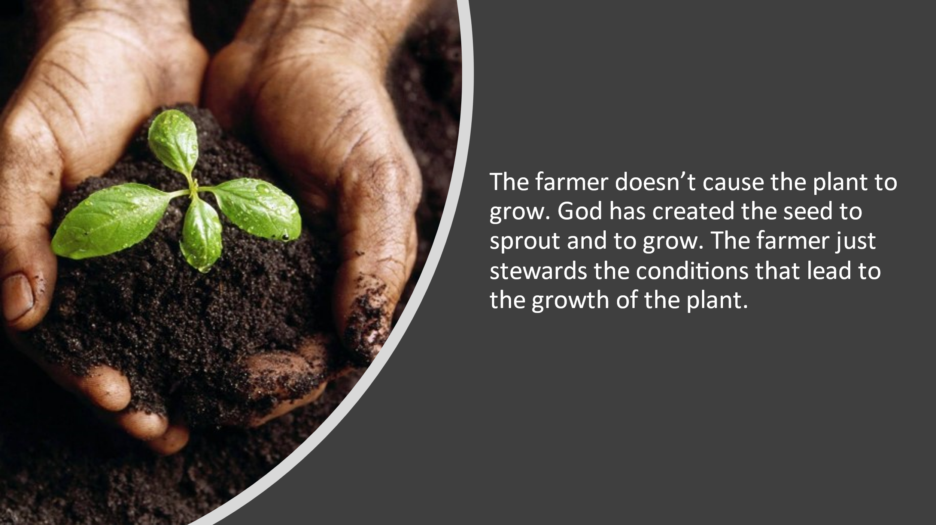
  - He has to see that it’s watered and fed.
  - The plant has to have access to the right kind of sunlight.
  - Eventually when enough things have been done to rightly steward the growth of the plant there is growth and eventually a harvest.
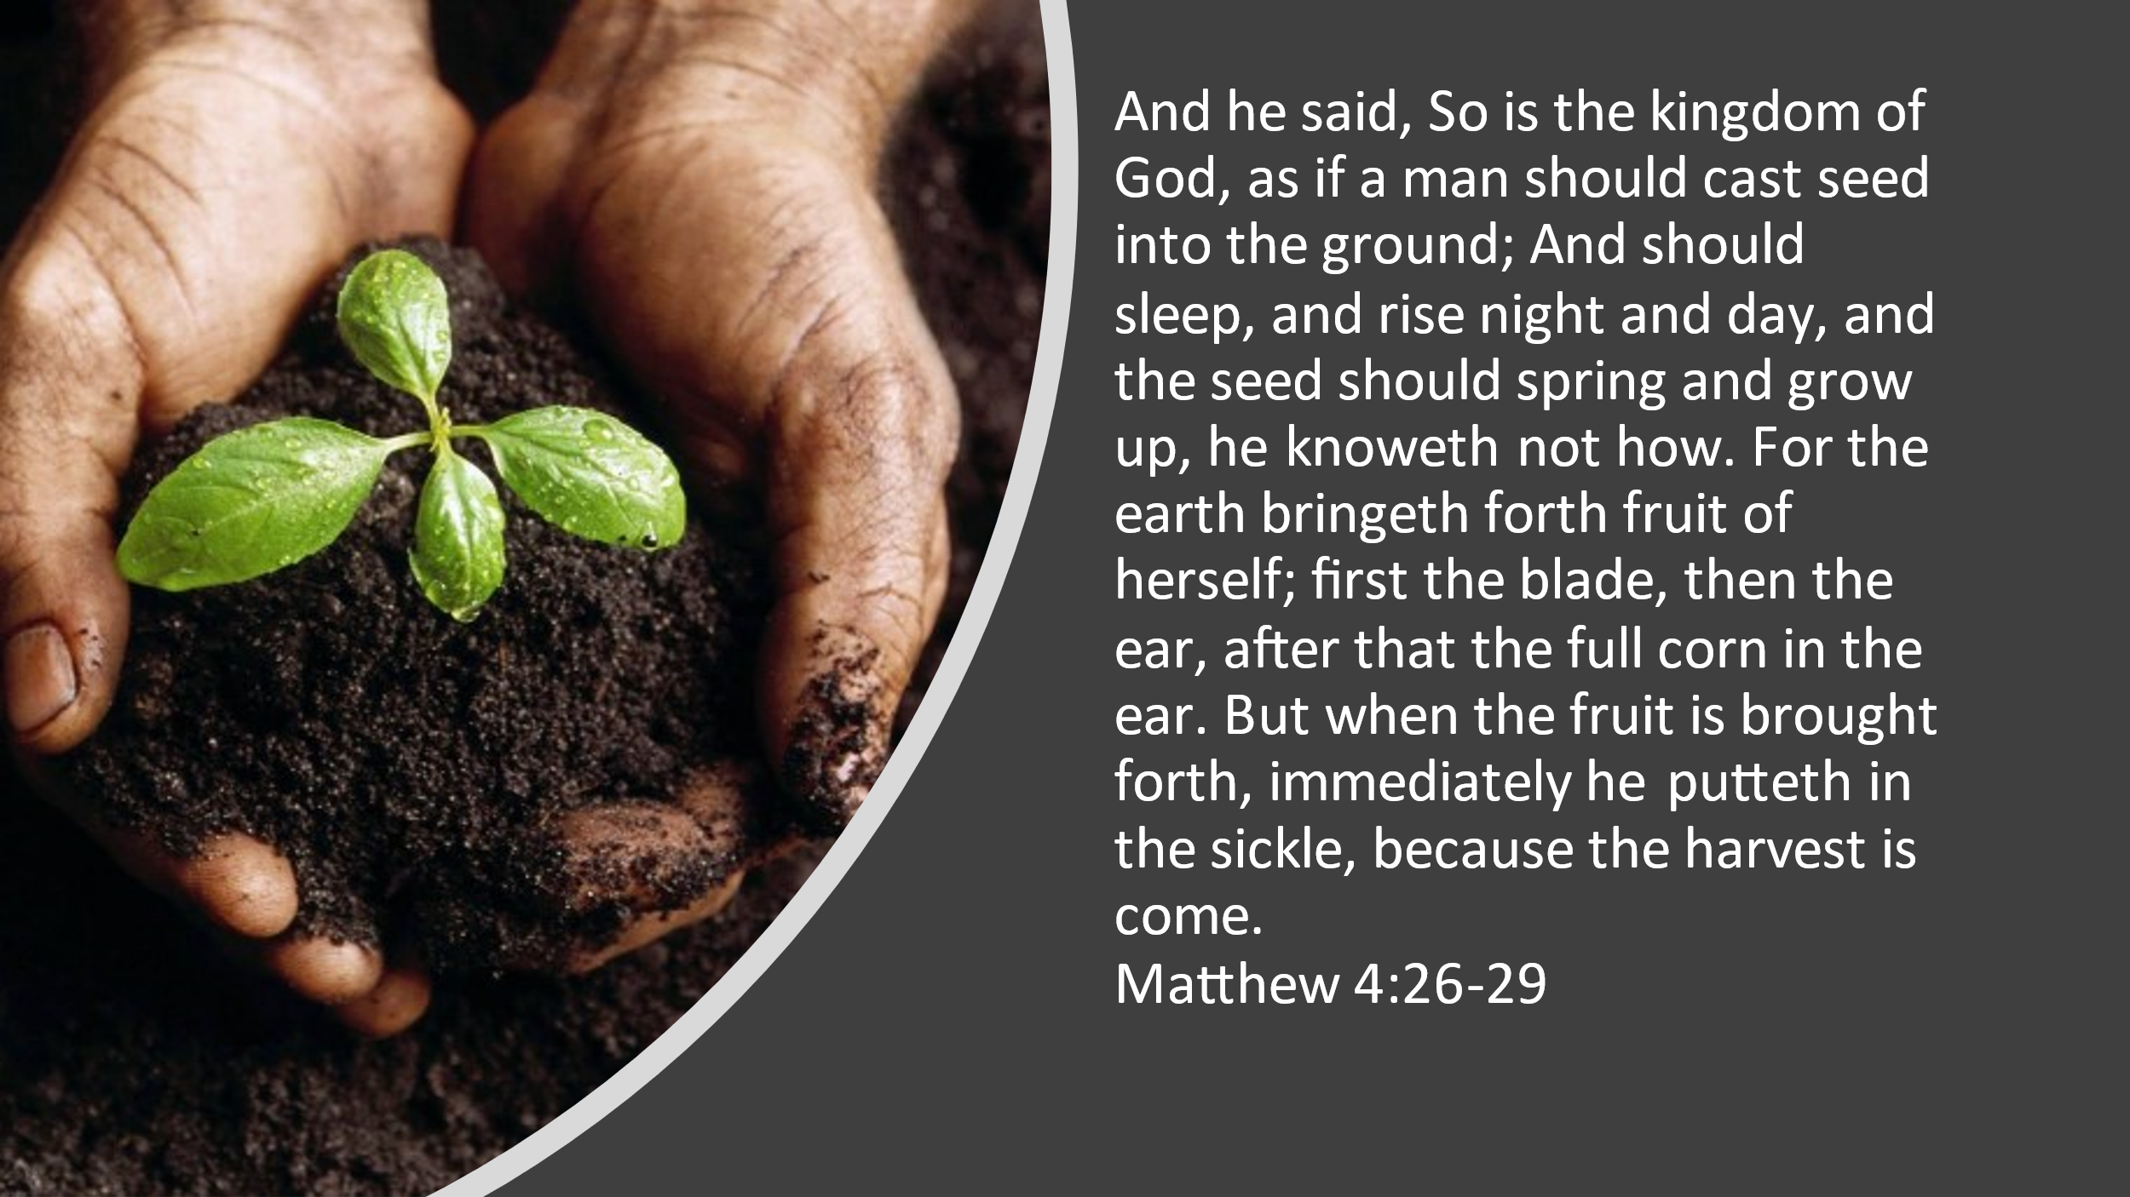
- The farmer doesn’t cause the plant to grow. God has created the seed to sprout and to grow. The farmer just stewards the conditions that lead to the growth of the plant.
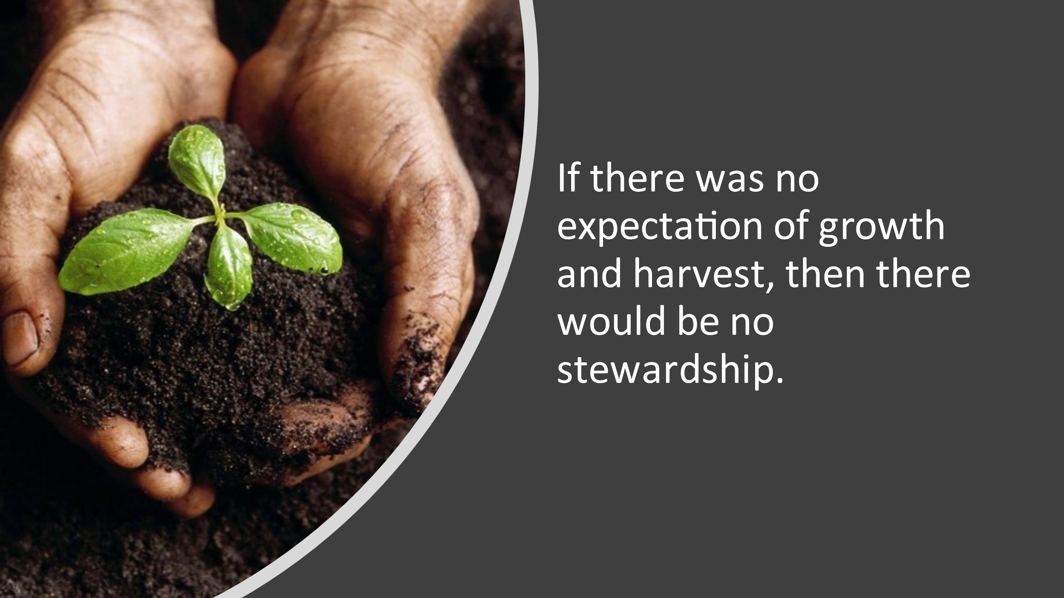
  - (Mar 4:26-29)- And he said, So is the kingdom of God, as if a man should cast seed into the ground; And should sleep, and rise night and day, and the seed should spring and grow up, he knoweth not how. For the earth bringeth forth fruit of herself; first the blade, then the ear, after that the full corn in the ear. But when the fruit is brought forth, immediately he putteth in the sickle, because the harvest is come.
- Now think about this- If there was no expectation of growth and harvest then there would be no stewardship.
- If the farmer never expected that planting the seed, watering the seed, and stewarding all of those things would lead to a harvest, then the farmer would not take a stewardship of the seed. No planting, no watering, no harvest.
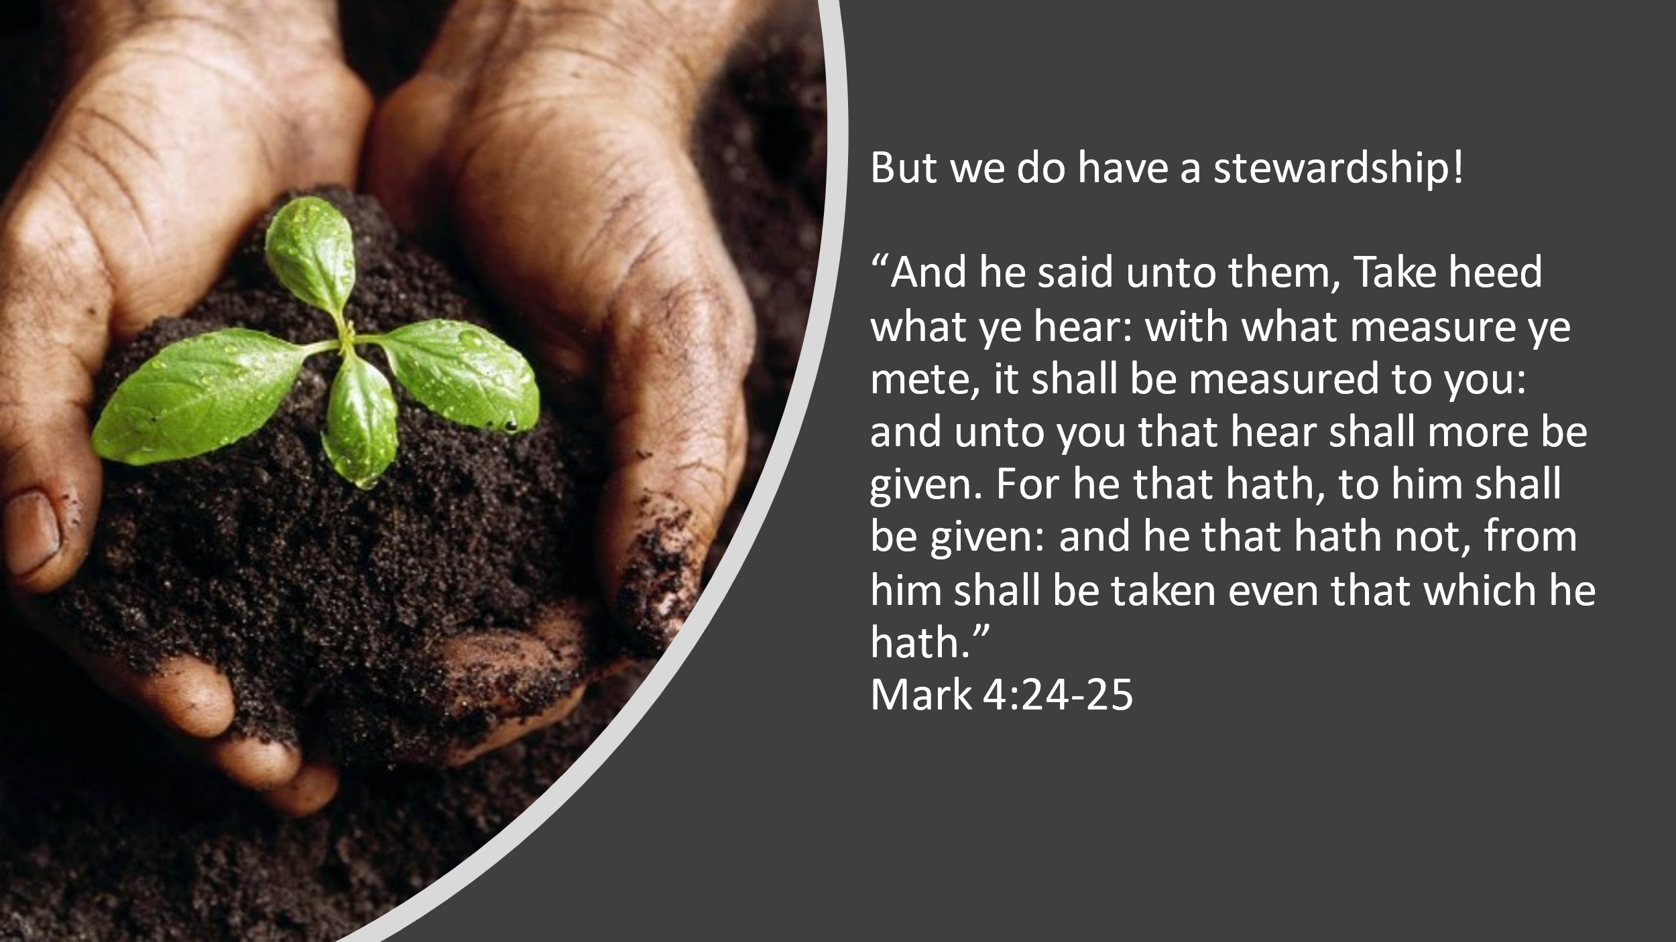
- But we do have a stewardship…
- Mark 4:24-25 And he said unto them, Take heed what ye hear: with what measure ye mete, it shall be measured to you: and unto you that hear shall more be given. (25) For he that hath, to him shall be given: and he that hath not, from him shall be taken even that which he hath.
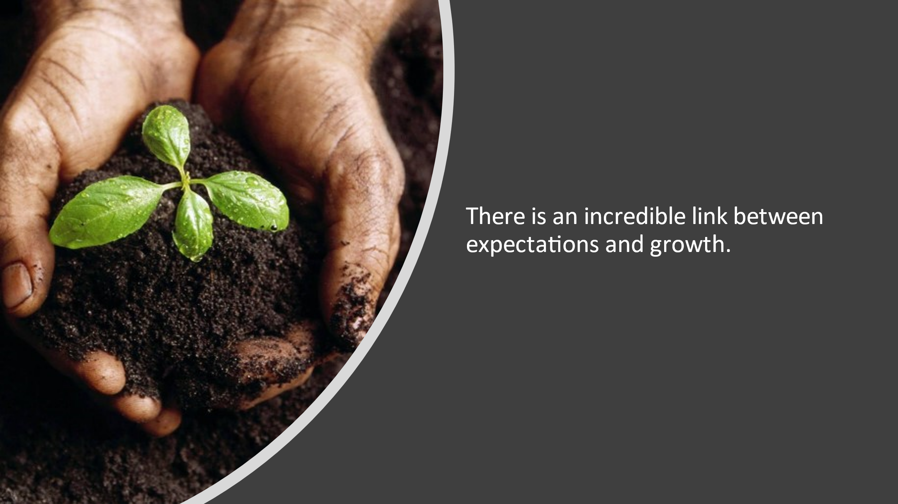
- And so anyone who has a stewardship of the gospel should have some expectations.
- There is an incredible link between expectations and growth.
  - Illustration: A student pastor is said to have asked the famous British preacher Charles Spurgeon how he could be more effective in bringing unbelievers to faith. Spurgeon reportedly asked the student, “Do you expect converts every time you preach?” The student responded that, of course, he did not. Spurgeon replied, “That is why you have none.”1
- Now I am going to show you some more pictures and I am going to ask you a question. Again, answer this to yourself:
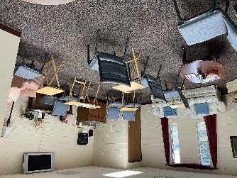



What do you see?


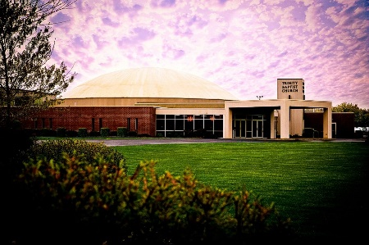
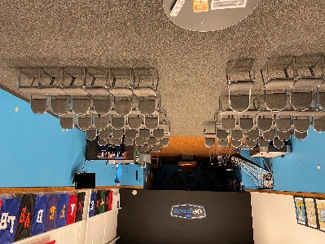
- What do you expect God to do through your Sunday School or ABF class?
  - Sadly, the answer from many Sunday School leaders today is the same as Spurgeon’s student: “Of course not.” That’s probably one reason Sunday School is struggling in many churches.
- If what gets us from seed to harvest in the plant world is a stewardship that is driven by expectations, is that principle transferable to our Sunday School classes?
- Absolutely it is!
- 5 minute Discussion: What are some great expectations that you as leaders should have of yourselves? Of your class?

What are the great expectations that your Sunday School class should have in order to see both spiritual and numerical growth?

Expectation #1- A Great Expectations Class expects new people and a great bible study experience every week.

- Perhaps the most important distinction of the Sunday School movement is the practice of open groups. What does that mean? Long white papers have been written to answer the question “What is an open group?” One answer is: “An open group is not a closed group.” But that contrast requires explanation too (which I’ll try to provide below). After many years of struggling to come up with a compelling but short definition of open group, I think I’ve discovered one. Here it is:
- An open group expects new people every week.
- The practice of open groups is the foundational principle of a Great Expectations Sunday School ministry or class. If a Sunday School really expects new people every week, that expectation will drive everything else it does before, during, and after a newcomer experiences it. And it always expects new people every week!
- There are some models that are a closed group model. The in home small group movement in an example. These are groups that don’t expect new people every week. Closed groups aren’t bad groups, they are just closed. Sometimes a closed group model allows for things that an open group model can’t. What is bad is to have a closed group in an open group model.
- At CBT we want open groups! We want to have an expectation that new people are going to come every week.

If our Sunday School classes are going to be open that means:

1. No Throwaway Sundays
  - “We may have been off a little this week; but if you’ll give us another chance, I think you’ll like it better next time.”
  - Maybe you’ve had that conversation with a guest. Perhaps you just wished you could have that conversation!
  - A lot of Sunday School classes—and, for that matter, churches in general—seem to have the idea that people average out their experiences before making a commitment to regular attendance. That idea is a faulty one. For most people, their first experience will carry more weight in that decision than all of the experiences that follow it—if there even is another experience.
  - Newcomers don’t average their experiences the way long-term attenders do. Here’s the reality. Every week may be somebody’s first week. If it’s not a good week, they may never come back for a second week to average or compare.
  - A Great Expectations Sunday School class knows it cannot afford any throwaway Sundays—Sundays when they decide, consciously or subconsciously, to let things slide a little, put it on autopilot, or take a vacation—maybe because the leader is on vacation!

2. The Psychology of Invitation
  - If your class is consistently driven by an every-week expectation that new people may be present, members will learn to trust in that consistency. The result is the removal of a significant psychological barrier that makes members less hesitant to invite new people to Bible study. That’s what I call the psychology of invitation.

3. Anyone is Welcome Any Week
  - Of course we would all affirm that new people (especially unchurched and unsaved people) are welcome in our class every week. That’s what we could call a “theology of invitation”.
  - The Bible tells us compel others to come and see.
  - But sometimes we do things that pit theology against sociology. Usually, these are not intentional actions. They grow from a sort of group subconscious. You see, there is also a sociology of invitation. The natural inertia for a small group, a class, or a church is to become a closed group. It takes almost no effort to become closed. It’s the predictable course of group dynamics. It takes great effort, on the other hand, for a group to intentionally remain open.

4. Leaders and Workers arrive early.
  - Many newcomers arrive early and many arrive slightly late. In either case, will you be ready for them?
    - Is there someone in your class ready to help meet guests up to 30 minutes early?
    - Are they good at introducing new people to others in your class?
    - In the ABF’s, have you made sure that you’ve gotten their information in a non-intrusive and polite way?
    - Does someone help by sitting next to them and then showing them how to get to the auditorium for the service, perhaps even sitting with them in the service?

5. The room communicates that we expect guests like you!
  - Have you ever had a guest over to your house for vacation and you found yourself having to explain certain idiosyncrasies about your house to your guests.
    - “Oh, yeah- that outlet doesn’t work.”
    - “In that shower cold is hot and hot is cold”.
  - Because we live there we become blind to things in our own house. We live with it. And if you’ve ever sold a house and fixed all of those things you may have thought, “Why didn’t I do all of this before?!”
  - Next time you go into your classroom try to look at it as someone who your class is trying to reach would look at it.
    - Would a 3rd grader think that this would cool? What about the third graders parent? Would they think that it was safe and fun?
  - When guests come over we make sure our house is ready to receive them. Is your classroom space ready for guests?

6. A great Bible study experience every week.
  - Let’s say everything has gone well for guests so far. They’ve been greeted warmly. They’ve been accompanied to their Sunday School classroom. Someone has completed the “Baptist paperwork” for them and has introduced them to the class. So far, so good. Now the moment of truth: the Bible study experience itself.
  - A Great Expectations Sunday School expects every class to have a great experience learning from the Bible every week. Every week? Yes!
  - A commitment to keeping Sunday School classes open both impacts and is impacted by the approach to Bible study. The most important principle is this:
  - Every individual Bible study session needs to be a complete and satisfying experience.

Discussion Questions:
- Does my class and its leaders expect new people every week?
- Is there anything that we’re doing that may make our class closed? (No expectation of new people and not very open to new people when they come).
- What are 3 things I can do to increase the openness of my class on Sunday morning to new people?

Session 2

- Allright- Session 2- Time to come back!
- So far we’ve said that a great and growing Sunday School class has some great expectations.
- These expectations are based on a stewardship that we have!
- Growth doesn’t come because of just 1 thing that we do. Growth comes because we’ve been a steward of the total ministry to the people that God has trusted to us.
- We said that the first Expectation a great Sunday School class has is that they Expect new people every week.
- Now just to remind us all of what we have tried to consistently say over the past year—The 3 tasks that the Sunday School is trying to achieve are these: We reach people, teach people, and minister to people.
- We have a stewardship of the Word of God and people. That is huge! And so, that means that we should have some expectations.

What are the great expectations that our Sunday School and ABF Classes should have in order to see both spiritual and numerical growth?

Expectation #2- A Great Expectations Class expects people to say yes!
- A Great Expectations Sunday School expects people to say yes! Yes to an invitation to attend Sunday School. Yes to an invitation to enroll in Sunday School. Yes to preparing for and participating in the class session. Yes to opportunities to serve in the class. Yes to the challenge of ministry and missions beyond the class. Yes to opportunities for training and development. Yes to starting new classes. Yes to new ideas—and maybe a few classic ones! Let’s deal with each of these briefly. The more people say yes to these elements of a Great Expectations Sunday School, the more people you can expect to reach and teach and minister through your Sunday School.

1. Yes to an invitation to attend.
  - I talked in the previous chapter about creating a culture of invitation and paying attention to its foundation, the psychology of invitation. How will you know if you actually have a culture of invitation? When members regularly invite new people to attend! How will you know if you and your members have a healthy psychology of invitation? When you expect those people to say yes to your invitation! After all, why wouldn’t they? Look at all the things you’ve done to get ready for company! You really expect new people every week, and it shows in dozens of ways large and small. And when they come, the Bible study experience is a dynamic one in every class, from the youngest preschool department to the oldest adult class. You’re ready! Now it’s time to start inviting people to attend, expecting them to say yes, with great confidence that they’ll say yes over and over again because of the wonderful experience they’ve had.
  - Now here is what I know. If you don’t have an expectation that people will say yes to an invitation to your class, you’ll never invite them.
  - But if you begin to see chances to invite as opportunities, and you expect people to say yes to an invitation…you’ll invite more people!
  - If leaders don’t invite people to their class, you can’t expect your class members to invite people to your class.

2. Yes to Enrollment.
  - The most foundational principle of Sunday School growth is open groups. A close second is the principle of open enrollment. The short definition of an open group is that it expects new people every week. Open enrollment has a brief definition too.
    - Open enrollment means people can belong before they believe.
  - They don’t have to believe the Bible. They don’t have to be a Christian. They don’t even have to like God! They just have to say yes to an invitation to enroll as members of the class, to agree to have their names placed on the class ministry list.
  - We call it a ministry list instead of a class roll because of the commitment each term implies. Being on a class roll implies that a member is committed to attending the class.
  - Being on a ministry list implies that the class is committed to ministering to the member—whether or not that person attends regularly.
  - That’s a big change in thinking for some classes. But it’s a healthy and necessary step toward becoming a Great Expectations Sunday School class.
  - In many churches, people get added to the enrollment once they come 4-5 times. This may make for less secretarial work but it is not a growth strategy nor is it a great way to minister.
  - Why? Because what you are saying is, once you’ve become committed to us then we will commit to you. Once you attend a certain number of times then we’ll begin to consider you to be a part of us and under our responsibility.
  - An open group says, We have a stewardship of anyone that will give us permission to minister to them.
  - What does that look like?
    - If someone comes to a church service or Sunday School class then we should follow up with that person to find out what their spiritual condition is.
      - Are they saved?
      - Have they been baptized?
      - Are they part of a local church?
    - It’s as simple as a phone call or visit asking if they’d like to know about things that your class is doing from time to time. If they say yes, enroll them!

3. Yes to the total ministry of the class.
  - If someone has given us permission to minister to them, then we must minister to them.
  - The more people we are ministering to, the greater opportunities for attendance and decisions for Christ that we have.
  - There is too much ministry that could be done than any one person could do.
  - I’ve had the following conversation with leaders over the years:
    - Teacher: I don’t have an outreach leader in my class.
    - Me: Yes, you do.
    - Teacher: I don’t have an inreach leader.
    - Me: Yes, you do.
    - Teacher: (Getting a little perturbed!) And I sure don’t have care group leaders.
    - Me: Sure you do.
    - Teacher: (On the verge of hitting me!) Why do you keep saying that?
    - Me: Because if you don’t have any of those positions, you own those tasks!
  - The reason many teachers don’t have helpers is that they don’t ask. The reason they don’t ask is that they don’t expect members to say yes. So ask people. And expect them to say yes.
  - Now, we’re going to talk more about what this looks like in the next and final session.
- 4. Yes to Evangelistic prayer.
  - Another possible first step might be to engage your class in intentional evangelistic prayer.
    - Put up a tear sheet or poster board on the wall and start listing the names of people who don’t know Jesus. Refer to it weekly as you get updates.
    - Celebrate when you learn that someone on the list has said yes to Christ.
    - The best way to tell whether a class is actually a small missional community is to listen to the prayer requests.
    - Do they increasingly concern the thing God cares most about: seeking, serving, and saving the lost? Are they voiced with great expectations that God will hear and answer those prayers and that we can be part of the answer?

5. Yes to Leadership Meetings
  - We have a gigantic job to do- Reaching, teaching, and ministering! It’s a job that needs to be done every week.
  - It takes training, communication, and teamwork to get that done. Starting in October we are going to invite all of our Directors and Teachers in the Sunday School, as well as ABF teachers and Care Group leaders to a monthly meeting on Sunday nights. It will normally be the 3rd Sunday Night of each month before the Sunday Evening service. The first one is going to be incredibly fun…I can’t wait to share that with you in our last session here today.
  - Why should we expect leaders to attend these meetings? As my friend Alan Taylor asks, “Why does the choir director expect choir members to attend rehearsal?” Is Sunday School less important than the choir anthem? Not if you have a Great Expectations Sunday School!

6. Yes to Training
  - Great Expectations Sunday School needs trained leaders. Unfortunately, many churches today don’t really expect leaders to say yes to opportunities for training.
  - I’m so glad that you are here today, and I believe that this training will help lead to more open, great expectation Sunday School and ABF Classes in our church.
  - Training helps us focus on improvement and what we’re trying to accomplish.
  - This is true for all of life- “If you only work in it and you never work on it eventually you may not have it to work in.”

7. Yes to planting new classes!
  - Healthy organisms reproduce. It’s how God designed the World.
  - New churches. New ministry teams. New Sunday School classes. They all produce growth!
  - Most classes will max out at about two years. Classes that have existed for more than a couple of years typically do not continue to grow, because they tend to become closed groups. Not necessarily on purpose. It just sort of happens. “Wait a minute,” you may protest. “New people join our class every year.” That’s almost certainly true. But is your class really growing?
  - How Do We Know if It’s Time to Reproduce?
There are several indicators that your class may be ready. One is that the growth of the class has plateaued. You may experience high-attendance days when attendance temporarily swells, but on average the class has a fairly predictable attendance.
Discussion Questions:
- Of all of the expectations to say yes, which one is our class the best at? Where do we need work?
- How can my class begin to pray for lost people in our class? Make a plan.

Session 3
- Now we’ve talked about 2 main great expectations that a growing Sunday School class has.
  - A Great Expectation Sunday School class expects new people every week. They are an open group.
  - A Great Expectation Sunday School class expects people to say yes.
- I hope that this has been very practical for you so far and that maybe you’ve picked up something that’s going to help you and your class do more than you’ve ever done before in terms of effectiveness as a class.
- If we have this incredible stewardship of the gospel, and the people that God gives to us, and the Word of God being planted into people’s hearts and lives…
- And as a church we are the largest organization mandated with that responsibility….
- Then it makes sense that this must be the last great expectation

Expectation #3- A Great Expectation Class expects that weekly ministry both inside and outside of the class will lead to spiritual and numerical growth.
- Let’s think through that….
- We know what inside and outside the class means. Inside the class speaks to what happens at the 9 oclock hour at the event called “Sunday School” or “ABF’s”. Outside the class speaks to what happens every other time.
- What about “spiritual and numerical growth”? That’s something we all long for, right? We want to see people making decisions to follow Christ, and growing/maturing in Christ, and getting involved in ministry for Christ. And we want to see that in more and more people’s lives.
- We have to define what “weekly ministry” means
- When it comes to ministry that needs to be done, ministry is best done through the conduit of relationships.
- If you don’t have a relationship with someone it becomes difficult to minister to them.
- What are some of the different kind of relationships that we have?
- One thing I have noticed is that right now each class only has one list. It is an attendance list. You got on the list if you attended the class. If you stop attending, then eventually you are taken off the list. This means that our list as they stand now are a list of people who were committed to us.
- We must recognize that a class must have a commitment to people inside and outside the class time to expect to grow.
- And that means we must have different lists that reflect where people are in their relationship to us and our relationship to them so that we know what ministry to them best looks like.

You can help your class to grow numerically and spiritually by recognizing 3 types of people who need ministry each week.

1. Guests

The primary ministry to our guests is a discernment ministry.

What do we want to know about guests?
- Are they saved?
- Have they been scripturally baptized?
- Are they a member of a Bible believing church?
- Can we minister to you? (Permission)

Class Members
- The primary ministry to those on our enrollment, or ministry list, is to stay connected with them.
- Remember that what governs people being on this list in an open group, with open enrollment is permission.
- We connect with them when they come to the event called Sunday School at 9:30am.
- We stay connected with them even when they are absent through the organization called Sunday School Class.
- We are concerned with people who are out of their attendance pattern.
- If someone is absent then someone from the class ought to be responsible to know where they are, what is going on in their life, and to contact them. In our classes we can do that through care group leaders. These people love their group, get to know their group, pray for their group, and interact with their group weekly through communication in class, or by MTV. (Mail, Telephone, Visit- whatever is appropriate.)
- The person who comes for the first time to a service who would fit in your class, or the one who actually comes to your class also needs a connection.

Prospects
- Prospects are those for which the spiritual condition is already discerned that we are trying to reach. More relationship with them and prayer for them is needed.

Summary:

A Great Expectation, Great Commission Sunday School Class expects new people every week, expects people to say yes, and expects that weekly ministry inside and outside the class will result in spiritual and numerical growth.
- A Great Expectation Sunday School class makes it a goal that no person and no ministry opportunity slip through the cracks.
- There is more ministry to be done than any one of us can do.
- We can and should organize and equip people in our Sunday School classes to minister inside and outside class time to reach teach and minister to those that God gives us.

So, what’s next?
Here are some first steps that you can implement immediately. It’s as easy as ABC
- A- Arrive early
- B- Begin Evangelistic Prayer for Easter and promote inviting tomorrow.
- C- Come to the new 412 Leadership Meetings starting in April (Ephesians 4:12). They will happen at 4:12 on the third Sunday of the month.
Coming Soon:
- Recruitment- I’ll be helping to recruit and train leaders who can help us stay connected to the people that God gives us and to reach new people for Christ.
- Realm Connect App- to help you connect with your class and get information that will help you contact and minister to them easily.
- Resources- We will be resourcing those who teach with lessons, lesson helps, video and audio resources and more.
- Reaching- Outreach and Evangelism Opportunities
- Reproduction- Making our discipleship process very clear so that we can reproduce more believers and leaders.
- Much more!

